Downtown Fargo Street Flag Program
Resource Guide

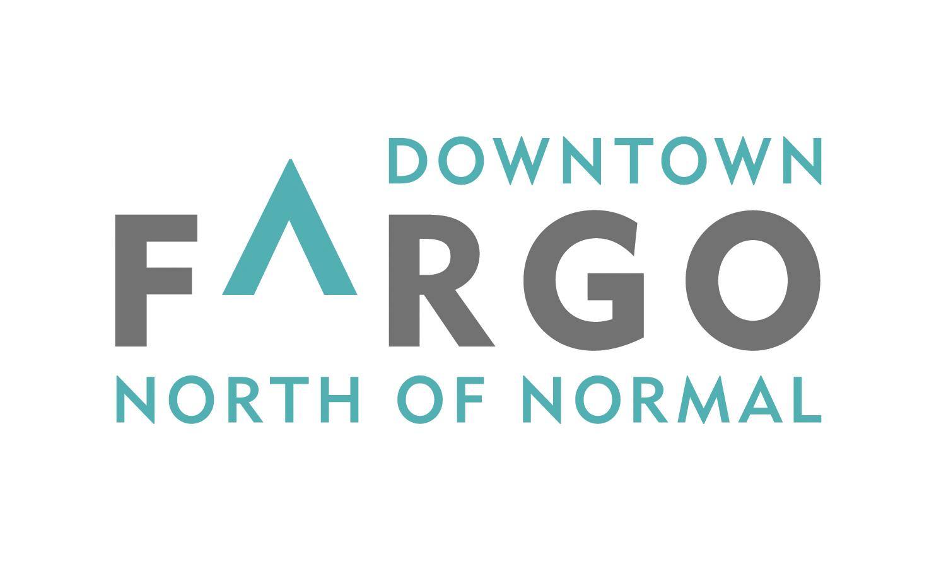

Downtown Community Partnership
210 Broadway, Suite 202
Fargo, ND 58102
Phone: 701-241-1570
Fax: 701-241-8275
downtownfargo.com

Downtown Community Partnership
The Downtown Community Partnership (DCP) is a non-profit development corporation for the Downtown district. On a daily basis, the DCP is involved in the planning and coordination of events and activities that attract thousands to Downtown. The DCP also leads efforts within the community to shape public policy that advocates for the betterment and enrichment of Downtown. The DCP drives initiatives in marketing Downtown as vibrant, clean, and safe.

Broadway Street Flags Overview
The Broadway Street Flag Program was created by the DCP in 2004 to improve the aesthetic appearance of the Broadway Streetscape and to help identify this place in our community. It has a goal of acting to identify areas where there is intense retail opportunity for visitors.

- Flags mountings along Broadway extend from Main Avenue to 6th Avenue North. There are a total of 66 light poles along this route.
- Flag mountings along 8th Street extend from Main Avenue to 1st Avenue South. There are a total of 12 light poles along this route.
- Flag mountings along Main extend from 7th Street South to 5th Street South. There are a total of 17 light poles along this route

The light poles are the property of the City of Fargo while the flag holders are owned by the DCP. Each flag holder is capable of accommodating up to two flags per pole.
Access will be adjusted as needed to accommodate construction projects.

Eligibility
Broadway Street Flags are an effective way to convey information about special events and activities that are located in Downtown or directly relate to and/or impact Downtown Fargo.
To be eligible, applicants must be a non-profit organization. The flags should showcase an event or attraction that is considered relevant to a large segment of the local community and associated with Downtown. Flags shall be used for non-commercial and non-political purposes. Priority will be given to the following (not ranked):

- DCP produced flags that promote an image of Downtown Fargo or publicize DCP events.
- Flags promoting public/community events/organizations or activities held Downtown, at North Dakota State University, Minnesota State University Moorhead, Concordia College, NDSCS, M State or Tri-College University or their successors.
- Patriotic flags to be used for events such as the Fourth of July or St. Patrick’s Day celebrations/parades, Memorial Day, Veteran’s Day, Flag Day, or Labor Day. Flags representing the branches of the US Military, POW flag or recognized Veterans organizations (examples include VFW, American Legion or AMVETS).
- A flag representing the City of Fargo, an official state or Tribal Nation flag.
- The DCP may also approve use for citywide special events or activities open to the general public and hosted in part in the downtown or having a downtown affiliation.

The following will not be allowed:

- Commercial advertising for private businesses or non-community events.
- Political advertising, including those intended to make/promote a public policy position.
- Logo or references to tobacco, alcohol, drugs, profanity or other related topics, images or graphics that are deemed offensive or inappropriate as determined by the DCP.
- Use of the words “sponsored by” or similar verbiage.
- Private business logos.

Flag Construction Specifications
Flag holder accommodate up to two flags. The recommended dimensions for each standard flag not to exceed 36” wide by 24” high attached to a wooden dowel (oak preferably) with dimensions of 36” in length (maximum) and 3/4” diameter. Flags must be made of nylon, plastic or a similar durable material; paper is not allowed. Strong winds are common in Downtown Fargo. Dowels not meeting the recommended specifications are prone to snapping off during periods of high winds. The DCP/BID are not responsible for wind damage.

The display of flags is generally limited to not exceed fourteen (14) continuous days.

Participants Responsibility
It is the responsibility of the applicant requesting the use of the flag holder to develop a design proposal, manufacture, install, and remove flags. The install and removal dates shall be specifically identified in the application. The DCP is responsible for reviewing the flag design, coordinating rotations and ensuring quality control standards are in place.
The DCP is not responsible for the disappearance of or damage to flags from any cause including but not limited to wind, weather, theft, vandalism, or fire. Once the application is approved and finalized, it is recommended that the participant order at least 12 additional flags for use as replacements in the event of damage or disappearance.

Flags must be installed and removed by the sponsor within the dates specified in the agreement. The organization has the option to request the BID to install and remove flags at cost of $200.00. Failure of participants to pay costs constitutes grounds for non-renewal.

Reservation and Program Costs
Reservations will be accepted up to one (1) year in advance on a first-come, first-serve basis. At minimum, applications shall be submitted ninety (90) days prior to the event. All applicants must submit a completed application along with a $250 application/use fee to the DCP for 1-7 days of use and an additional $250 use fee for an additional week (8 days up to 14 days total). If an application is not approved, the application fee will be refunded in full.

Blackout Dates
U.S. Flags will be placed along Broadway, Main, and 8th Street during Memorial Day Weekend, Flag Day, Fourth of July, Labor Day Weekend and Veterans Day Weekend. During these periods, only U.S. Flags will be allowed to be placed in the flag holders.

Flag Design Guidelines
Street flags are different from most graphic designs. They are generally viewed quickly from sidewalk pedestrians, drivers and their passengers driving down Broadway. Therefore, the message needs to be conveyed rapidly. A small number of design elements, bright, contrasting colors and large clear typography are common elements of a successful flag design.

Review Process
Applicants must submit the design of flags to the office of the Downtown Community Partnership at least 90 days prior to the proposed installation date. Applicants must receive joint approval (in writing – either letter or email) from the DCP Executive Committee and the City of Fargo. An applicant can expect notification within 30 days of submittal. Applicants are strongly encouraged not to have flags produced prior to approval.
One-time approval does not guarantee or imply approval in future years.
Please mail the attached application, proof of non-profit status, proof of liability insurance and non $250 application fee for one week use or $500 if more than 7 days but generally not to exceed 14 continuous days to (all at a rate of $250/week):

Downtown Community Partnership
210 Broadway, Suite 202
Fargo, ND 58102
Phone: 701-241-1470
Fax: 701-241-8275
downtownfargo.com

Considerations
- On average, it takes a two person team between 12 and 16 hours to install and remove flags from the flag holders.
- To properly install and remove flags, a wrench with a 7/16” socket or pliers is required.
- There are two holders per pole for participants/sponsors to utilize.
- A typical block has about 10 light poles with flag mounts or up to 20 flags per block.
- Every flag holder does not have to be used for an event. This is up to the organization.
- If both flag holders on a light pole are requested to be used, the requesting organization will automatically incur the $200.00 install and removal fee as the DCP utilizes seasonal flags year round and the BID will have to remove the DCP flags.

APPLICATION FOR DOWNTOWN FLAG HOLDERS
Applicant/Organization: ____________________________________________________
Address: ________________________________________________________________
City: _________________________ State: _________ Zip: ____________________
Contact Person: _______________________________ Phone: __________________
Email Address: ____________________________________________________________
Purpose of Flags: __________________________________________________________
Dates Requested: ____________________________ to ___________________________
- Is the design the exact same as has been previously used _____ Yes _____ No
- If not the same, you must provide a design or photo which needs to be approved in advance by the DCP.

- ______ Our organization will mount and remove the flags.
- ______ Our organization will pay the BID $200.00 to install and remove the flags.
Note – most groups generally limit their use to 7 consecutive days.
Other items to include in this application:
- Design with colors of the flag design.
- Proof of non-profit status (IRS Determination Letter).
- A $250 application fee payable to the DCP for up to one week and $500 total if more than 7 days but not to exceed 14 continuous days. Prorated at $250/week thereafter.
- Proof of liability insurance.
- Install and removal dates.
Applications must be submitted at least 90 days prior to the proposed installation date. All flag designs must be approved by the Downtown Community Partnership Executive Committee and the City of Fargo. Applicants can expect notification (approved or denied) within 30 days of submittal. It is the responsibility of the flag applicant for requesting the use of the flag holder, developing a design proposal, manufacture, install, and removal of flags.
The DCP or BID is not responsible for the disappearance of or damage to flags from any cause including but not limited to wind, weather, theft, vandalism, or fire.
I have read and understand the Downtown Community Partnership Flag Policy. Further, I understand that permission is granted for the purpose of allowing private flags to be placed on public poles and that all responsibility for public liability, injury to persons and/or the City of Fargo. The DCP’s encroachment agreement is revocable by the City of Fargo at any time with no notice to the applicant.

________________________________________ ______________________________
Signed - Authorized Representative of Applicant Date

_______ Application is approved
_______ Application is denied

________________________________________ _____________________________
Signed - Authorized representative of the DCP Date

